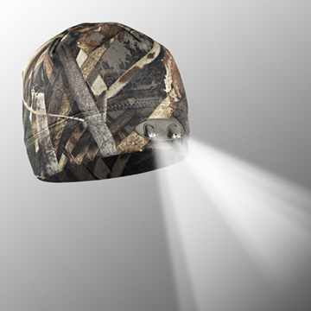

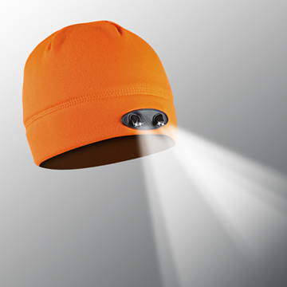
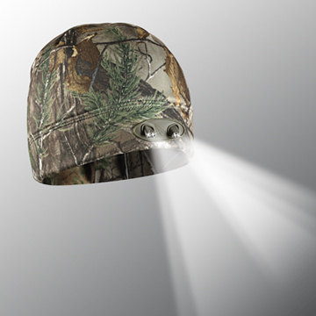
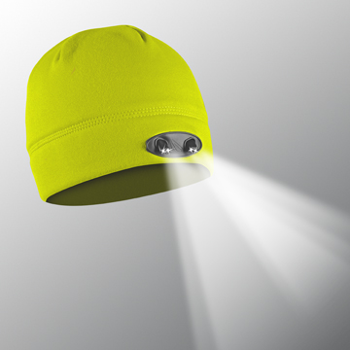
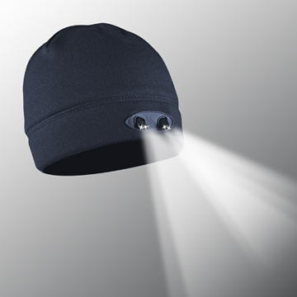
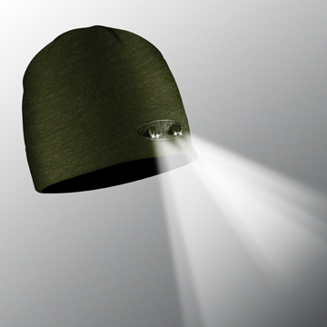
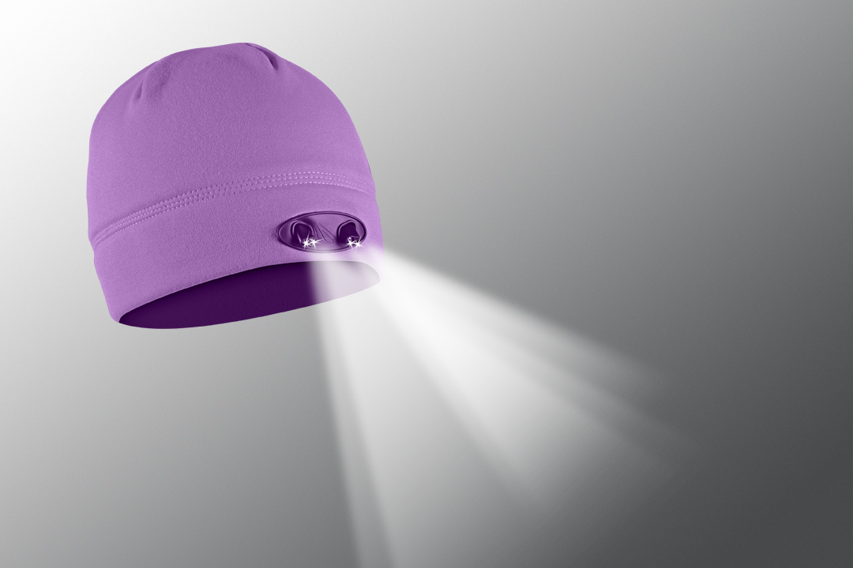
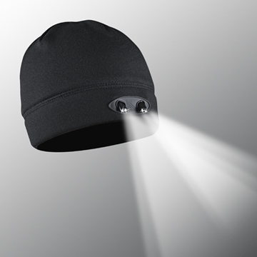
Great for work for play, young & old, men or women
Add your logo and advertise too...GIFTS DONE!
Lighted Beanies
Keep you warm, dry & light your way

VISIT OUR WEBSITE WWW.PANTHERVISIONPROMO.COM
TO SEE THE FULL LINE OF LIGHTED PRODUCTS
OR CALL 847.783.5900 x 116 FOR MORE INFORMATION

BLACK WB-4553
ORANGE WB-4546
REALTREE XTRA WB-4539
NAVY WB-4737
OLIVE WB-5505
HI-VIZ WB-5529
ORCHID WB-5628
Holiday stress getting to you?
Get the perfect gift for everyone.
Give the gift of
light this holiday season

Add your information here

POWERCAP® 35|55 LED
LIGHTED BEANIE
• Warm but NOT fuzzy. Anti-pilling compressed fleece with moisture wicking liner.
• Task and distance lighting to walk the dog, clear the driveway or put up those holiday lights.
• Decorate with your clients logo using embroidery or heat transfers
• Replaceable batteries
• Hand washable

As low as $16.84 with 5,000 stitches (s)

VISIT OUR WEBSITE WWW.PANTHERVISIONPROMO.COM
TO SEE THE FULL LINE OF LIGHTED PRODUCTS
OR CALL 847.783.5900 x 116 FOR MORE INFORMATION

REALTREE Max 5 WB-5659
WB-5628

VISIT OUR WEBSITE WWW.PANTHERVISIONPROMO.COM
TO SEE THE FULL LINE OF LIGHTED PRODUCTS
OR CALL 847.783.5900 x 116 FOR MORE INFORMATION

VISIT OUR WEBSITE WWW.PANTHERVISIONPROMO.COM
TO SEE THE FULL LINE OF LIGHTED PRODUCTS
OR CALL 847.783.5900 x 116 FOR MORE INFORMATION

